Minimal Retransmission and Reliable Routing Protocol
Ngoc-Huy NGUYEN¹ and Myung-Kyun KIM¹
¹ University of Ulsan, 44610 Daehak-ro 93, Nam-gu Ulsan, South Korea
{huynguyen.haui1412@gmail.com, mkkim@ulsan.ac.kr}
Abstract. The Internet of Things is expected to transform our world in the future require low-power operations, reliable communication with tighter deadlines. One of the approaches is to construct a routing tree that can satisfy reliable communication. However, it is not easy to construct a tree that has a reliable path due to the wireless links are unreliable. Each node has to know the link quality of the other nodes in the network to establish the metric to find the path to satisfy the application requirements. Thus, we propose a decentralized routing algorithm called Minimal Retransmission and Reliable (MRR) to efficiently construct a routing tree that almost optimal for reliable transmission with low-power operations. Furthermore, we devise a way to increase the parallel transmission in the constructed tree. We apply the Path Collision-aware Least Laxity First (PCLLF) scheduling algorithm to the constructed tree and evaluate the new approach with RPL. According to the simulation result, the network using MRR routing protocol outperforms RPL protocols in terms of packet delivery ratio and energy consumptions.
Keywords: IEEE 802.15.4e, Wireless Sensor Networks, Routing Protocol, Link Burstiness, Reliability.
- INTRODUCTION
In the past decade, the Internet of Things applications using wireless sensor networks (WSNs) received the attention of both academics and industrial all over the world. It typically consists of a number of sensor nodes with sensing, wireless communication, and computation capabilities. These sensor nodes sense the physical environment, collaborate to gather the data for application purposes, for example, environment monitoring, industrial control system, military surveillance. Many applications are deployed in an ad hoc fashion without planning. The sensor nodes are able to autonomously organize themselves in the network. In most cases, it requires network protocol to implement various network control and management functions such as synchronization, measure link quality, and network security. There are many limitations in typical routing protocols when applied to WSNs, primarily due to the energy-constrained design of such networks [Wireless Sensor Networks: A Networking Perspective]. Flooding, for example, is a technique in which a given node transmits the data and control packets that it has received to the rest of the network nodes [Routing Protocol in Wireless Sensor Networks, Routing Protocols in Wireless Sensor Networks – A Survey]. It repeats this process until the destination node is reached. Since flooding is a blind technique, duplicated packets can keep circulating throughout the network, and these duplicated packets are received by sensors, creating an implosion problem. Also, if two sensors sense the same region and simultaneously transmit their sensed data, duplicated packets will be received by their neighbors. Another strategy for overcoming the shortcomings of flooding known as gossiping can be used [Efficiency of the Gossip Algorithm for Wireless Sensor Networks]. When gossiping, a sensor will randomly pick one of its neighbors when receiving a packet and send the packet to it. Until all sensors receive this packet, the same process repeats. Using gossip, only one copy of the packet sent will be received by a given sensor. There is a substantial delay for a packet to reach all sensors in a network while gossiping addresses the implosion problem. In addition, as the number of nodes in the network increases, these disadvantages are emphasized.
Many research tries to improved the data throughput to reduce the data gathering period while ensuring real-time and reliable transmission.
- RELATED WORK
  - System and Network Model
In this study, we focus on the converge cast multi-hop networks that consist of one sink and some sensor nodes that are constructed into tree topology. All nodes are assigned identification numbers and deployed randomly during network configuration. All sensor nodes transmit data to a sink periodically along the tree path. Two nodes are said to have a link if they can transmit directly to each other and a link on which a child and parent node communicates together is a tree link.

Figure 1. An example network topology.

- Minimal Retransmission and Reliable Routing Protocol
In this section, we propose the Minimal Retransmission and Reliable Routing Protocol (MRR) that using our Burstiness Distribution Metric to find the minimal retransmission path and reach our target PRR for reliability. We use the network topology as Figure 1 and use the number of probes in 1000 packets in MLQP. We use the config Directed Graph Radio Medium (DGRM) mode in Cooja Simulation to set up the PRR value and to form the link between two desired nodes excluding the others as Figure 2.
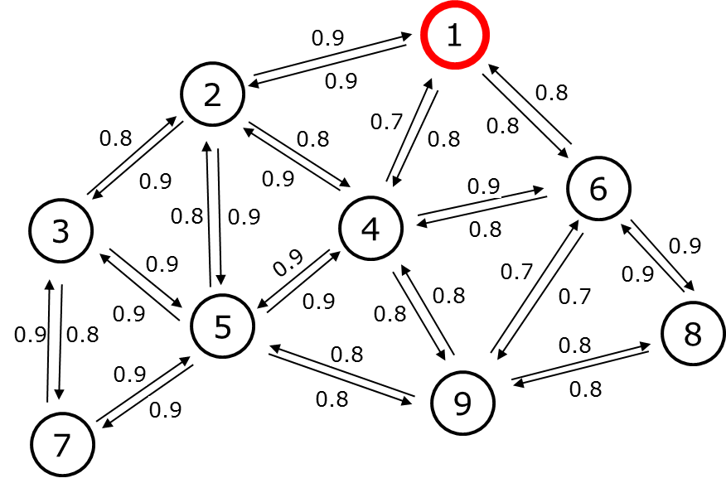
Figure 2. Network example with the PRR of each link.
After the MLQP, the receiver node calculates the number of retransmission for each incoming link of the neighbor node by using Burstiness Distribution Metric. Figure 3 shows the network graph with the number of retransmission as the metric value for the routing protocol.
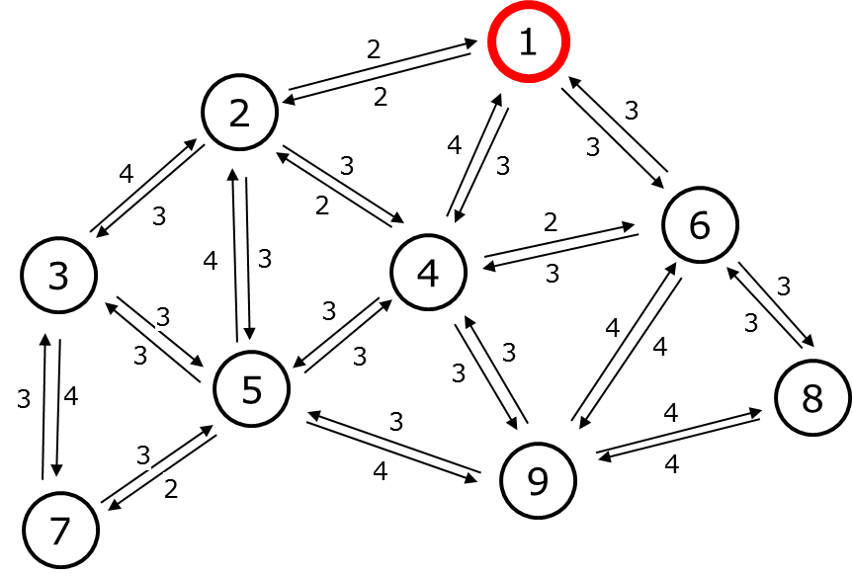
Figure 3. Network graph with the number of retransmission.
We only focus on the converge cast network here, so the MRR aims to find the path from the node to the sink and uses the number of retransmission as a route metric. Besides, the same approach can be applied for the download graph routing to control the node from the sink. In this paper, we only present the converge cast network. The route discovery process is performed by exchanging Route Request (RR) control packets between the node and the neighbor nodes. Each node maintains the neighbor list and the routing table for routing data packets. The routing table consists of a Route Entry (RE) with RE(p_{id}, h, r). The p_{id} denoted the parent identifier and h is the hop count, r is the rank calculated by the sum of retransmission through the path from that node to the sink node. The sink node will have RE(0, 0, 0) which means it doesn’t have a parent, the hop count is 0 and the rank is 0. The MRR starts from the sink node by broadcasting the RR control packet. The RR packet carries RR(s_{id}, h, [nbr_list(n_{id}, r)]) where s_{id} denotes the ID of sender node, h denotes hop count of sender node, and the nbr_list(id, r) denotes the neighbor list which contains neighbor ID (n_{id}) and the rank (r) of neighbor node calculated by the number of retransmission from this neighbor to sender node plus the rank of sender node. When a node Y receives RR(s_{id}, h, [nbr_list(n_{id}, r)]) packet from node X, it and creates a RE(p_{id} := s_{id}, h = h + 1, r = r). After that, if node Y receives another RR(s_{id}, h, [nbr_list(n_{id}, r)]) packet from node Z, it compares the newly create RE(p_{id} := s_{id}, h = h + 1, r = r) by the rank then the hop count. The lower rank is the better route due to the number of retransmission is minimal and if the rank is equal, we compare the hop count, the lower hop count is the better route. The node will send Route Response (RP) through the parent node in the routing table. The RP packet contains the path from the leaf node to the sink node. The sink node will save the path to check the Route discovery process is finish or not by check the number of nodes in the network compared with the number of nodes in the path received from RP.
For example, we use a network graph in Figure 3. The sink node is node 1 send the RR(1, 0, [(2, 2), (4, 4), (6, 3)]). Note that, the link quality estimator using Burstiness Distribution Metric that we present in the previous section is receiver estimator, so the sink node has the information of the number of retransmission from link L(2, 1), L(4, 1), and L(6, 1) is 2, 4, 3 respectively.
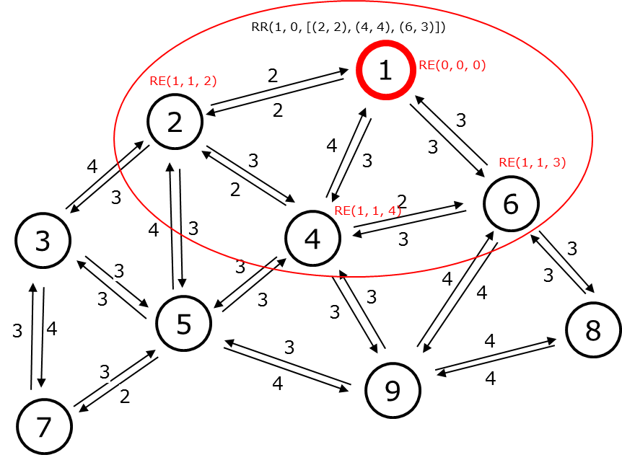
Figure 4. The sink node starts routing protocol by broadcasting the RR control packet.
When node 2, 4 and 6 receive RR(1, 0, [(2, 2), (4, 4), (6, 3)]) from node 1, node 2, 4 and 6 create the route entry RE(1, 1, 2), RE(1, 1, 4) and RE(1, 1, 3) respectively as Figure 4. After that, they create and broadcast their RR packet immediately as Figures 5, 6, and 7.
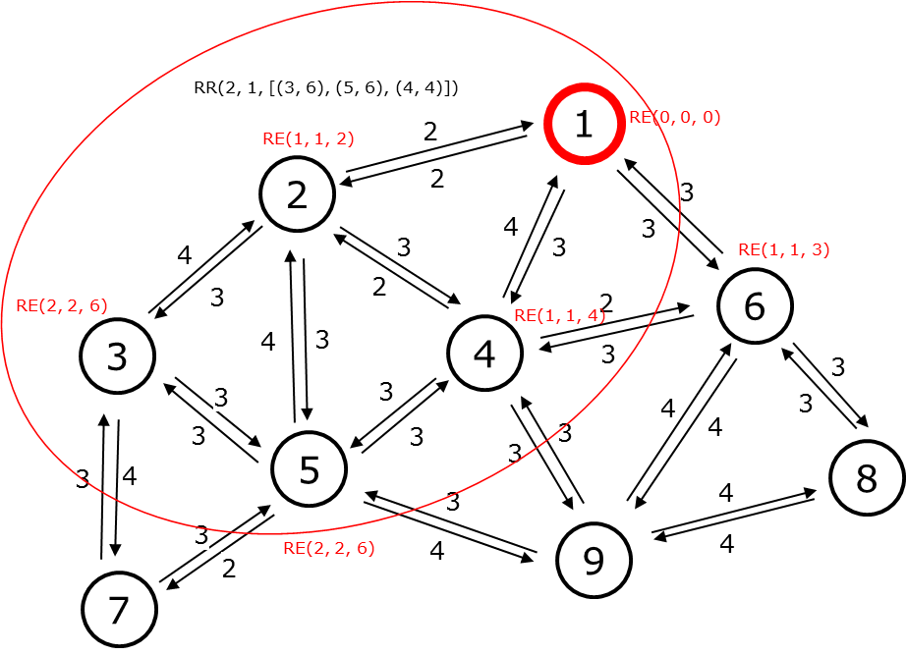
Figure 5. Node 2 broadcasting RR control packet and the neighbor create RE respectively.
Node 2 has the RE(1, 1, 2) after received RR from node 1. Neighbor node 3, 5, and 4 have the rank value of is the number of retransmission in link L(3, 2), L(5, 2), and L(6, 2) plus the rank of node 2. So it will create RR packet exclude node 1 RR(2, 1, [(3, 6), (5, 6), (4, 4)]). In this case, node 3 and 5 create new RE(2, 2, 6) and RE(2, 2, 6). For node 4, because it creates RE(2, 2, 4) compare with RE(1, 1, 4) create by receiving RR from node 1. They have the same rank 4 but RE(1, 1, 4) has only 1 hop compare with 2 hops from Node 2 RE(2, 2, 4). So node 4 keeps the better RE value.
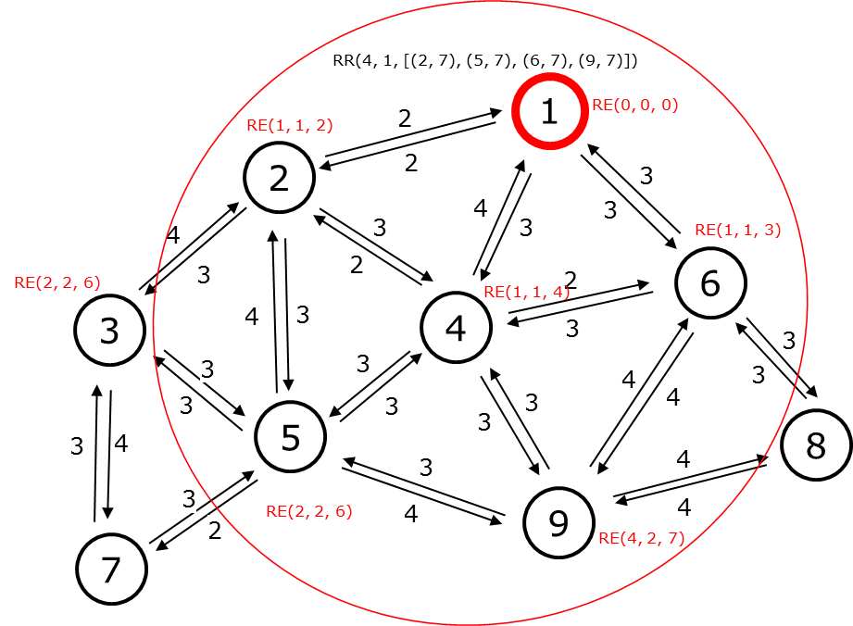
Figure 6. Node 4 broadcasting RR control packet and the neighbor create RE respectively.

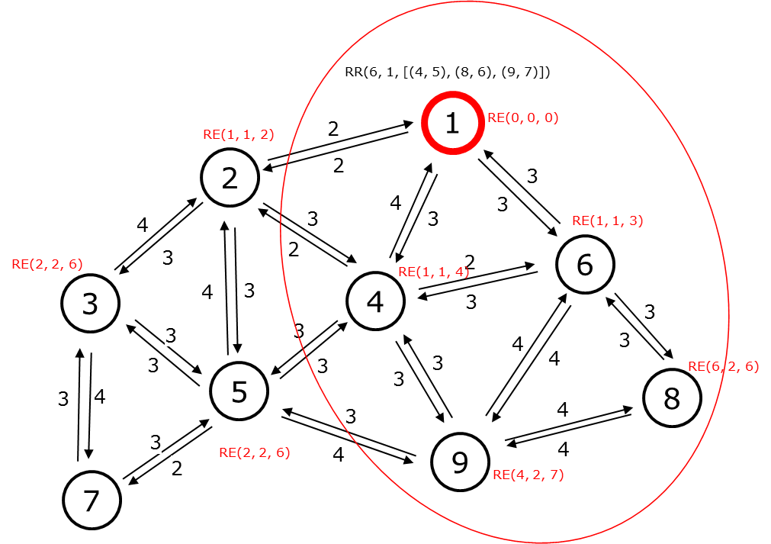
Figure 7. Node 6 broadcasting RR control packet and the neighbor create RE respectively.
The MRR route discovery runs the same operation until the network has the node received all RR control packet from its neighbor. Figure 8 shows the example for route response operation starts from Node 7. After receiving the RR packet from node 3 and node 5. Node 7 doesn’t create its RR packet due to all the neighbor nodes of Node 7 has a higher hop count than 7. Node 7 creates RP(7) which responds to the parent node 3 that node 7 chose it as a parent.
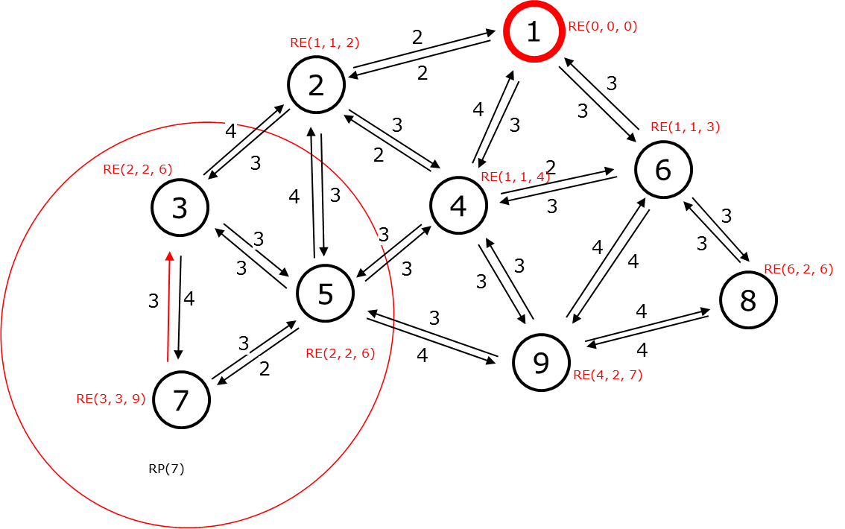
Figure 8. The route response operation from Node 7.
Node 3 after receiving RP(7) it updates RP(7, 3) then sends it to node 2 as Figure 9.
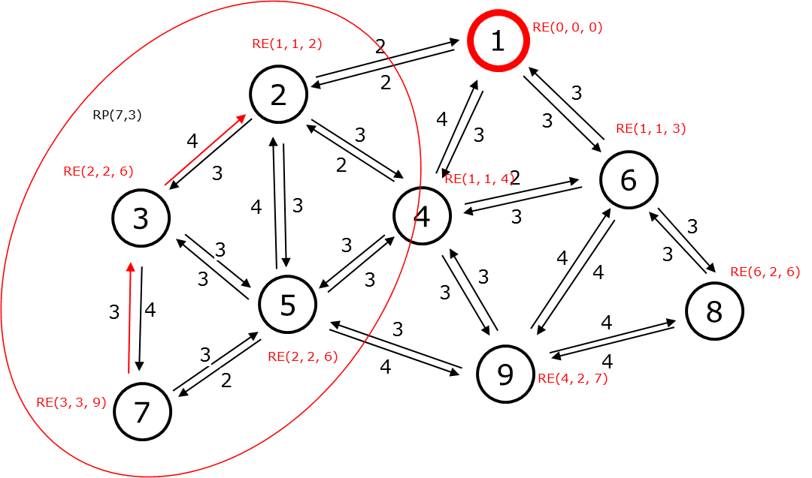
Figure 9. The route response operation from Node 3.
The RP operation will stop after the RP packet reaches the sink node. After the MRR routing protocol finishes. We have the converge cast tree topology of the example network as Figure 10.
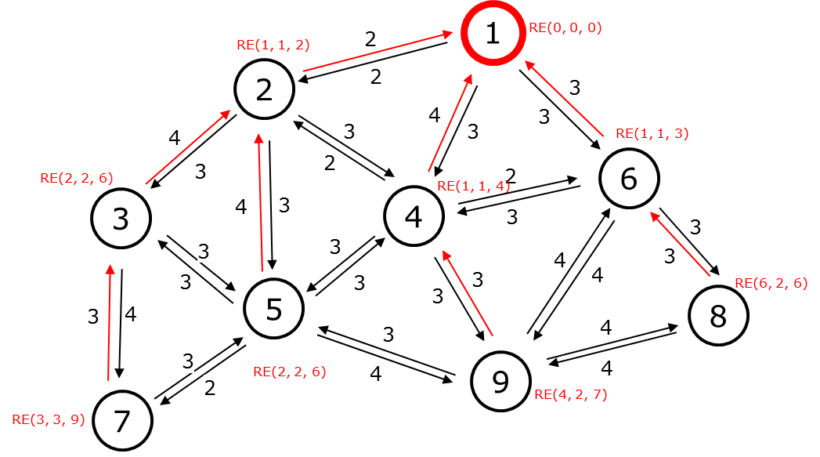
Figure 10. The converge cast tree topology of the example network.

- EVALUATION
- CONCLUSION

References

